**Homework 10: Theory of Angular Momentum**

**PHYS550 – Quantum Mechanics I**

**Gabriel M Steward**

**November 2021**

***Additional Texts Referenced: Introduction to Quantum Mechanics, Griffiths and Schroeter***

**Problem 1**

*Given a rotation in spin-1/2 ket space*

**

*Show:*

*a) U is unitary*

The generally easiest way to show that U is unitary is to show that UT*U is one—or, well, the identity. Luckily, we can do exactly that.

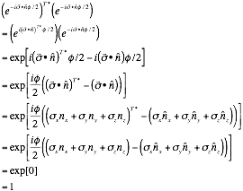

At which point we have shown what we were asked to. Note that the components of n are numbers, and the pauli matrices are known to be hermitian, so taking transpose conjugates does nothing to them.

*b) det U = 1.*

It was recommended we use the matrix form for this. So here it is:



So now we take the well-known 2x2 determinant.

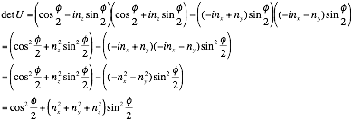

As the n terms are part of a unit vector, their squares must add to one.



Thus, detU=1, which was what we sought.

**Problem 2**

*In 3-dimensional real vector space, a rotation about the x–axis by angle α is given by the matrix*

**

*In the quantum mechanical 2-dimensional ket-space for a spin-1/2 particle, the representation of R is*

**

*Show:*

*a) *

Just so we’re all in the clear, we recall:



And we note that the **1** in our given relation is the identity matrix.

So now we attempt to show the relation given to us as a).

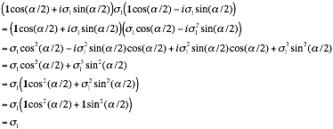

Which is what we sought to show.

*b) *

This only changes things because our U does *not* include σ2. Remember though, one pauli matrix times the other is the third times i with the sign determined by the epsilon order. We will use this to evaluate the desired relation:

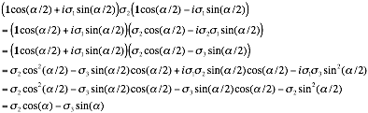

Where the last step is with the double-angle formulas.

*c)* 

All but identical to the above, just with 3 instead of 2 which swaps some signs around.

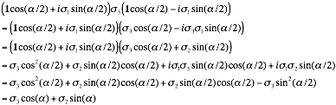

Which is exactly what we sought to show.